Review Problems for STAT 350

1. (One sample mean) Many consumers pay careful attention to stated nutritional contents on packaged foods when making purchases. It is therefore important that the information on packages be accurate. A random sample of n = 12 frozen dinners of a certain type was selected from production during a particular period, and the calorie content of each one was determined. (This determination entails destroying the product, so a census would certainly not be desirable!) Below are the resulting observations.
255 244 239 242 265 245
259 248 225 226 251 233
a. Construct and label a boxplot and normal probability plot for this data set.

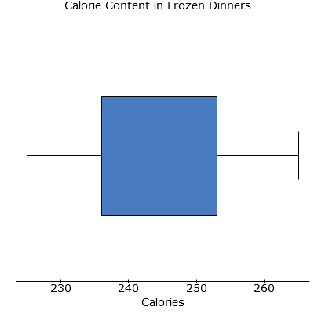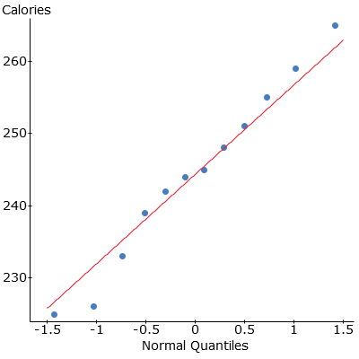

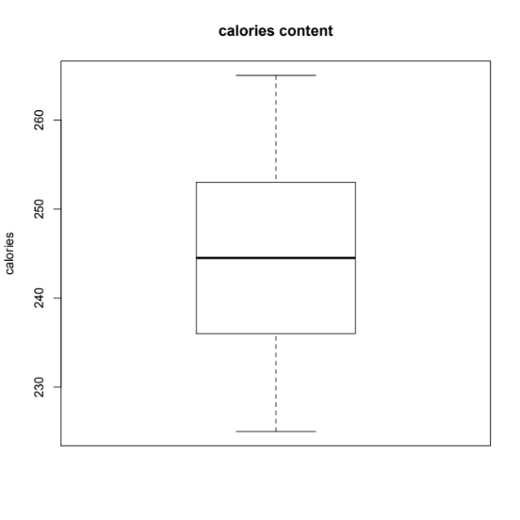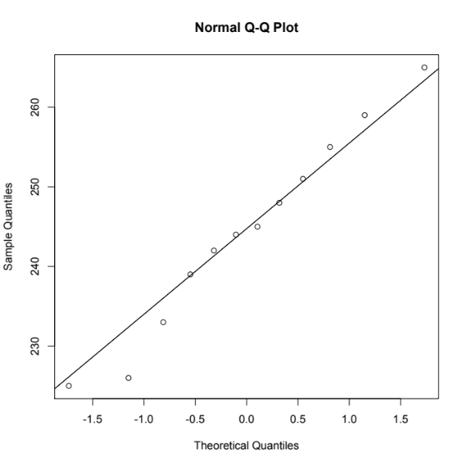

b. Is it reasonable to test hypotheses about true average calorie content µ by using a t test? Explain.

Yes, it is reasonable to use a t-test as the distribution of calories in this frozen dinner are symmetric (as seen in the boxplot) and the calorie content fall reasonably close to a straight line when plotted against normal quantile values which suggests that the calorie content data are likely approximately normally distributed.

c. The stated calorie content is 240. Does the boxplot suggest that the true average content differs from the stated value? Explain your reasoning.

The median value shown on the boxplot, which would be close to the mean value as the data set is symmetric, is slightly greater than 240.

d. Carry out a formal test of hypotheses suggested in part b.

Ho: μ=240
Ηa: μ≠240
μ is the population mean calorie content in the frozen dinners.
As we have verified that all conditions for a t-test have been met we can proceed.
The test statistic is found to be 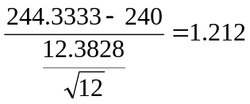
The p-value is found to be 0.25. This states that the probability that we obtain a sample such as this one or one more extreme is 0.25. As the p-value is very large we will fail to reject the null hypothesis.
0.25>0.05
There is no evidence to suggest that the average calorie content in these frozen meals is not 240 calories at the 0.05 level of significance.

2. (paris means)The effect of exercise on the amount of lactic acid in the blood was examined in the article “A Descriptive Analysis of Elite-Level Racquetball” (Research Quarterly for Exercise and Sport (1991): 109-114). Eight males were selected at random from those attending a week-long training camp. Blood lactate levels were measured before and after playing three games of racquetball, as shown in the accompanying table. We will use this data to estimate the mean change in blood lactate level using a 95% confidence interval.
Player | Before | After | Difference
1 | 13 | 18 | -5
2 | 20 | 37 | -17
3 | 17 | 40 | -23
4 | 13 | 35 | -22
5 | 13 | 30 | -17
6 | 16 | 20 | -4
7 | 15 | 33 | -18
8 | 16 | 19 | -3

x_{d} = -13.63 s_{d} = 8.28 n = 8
We will be conducting a matched pairs t-test.

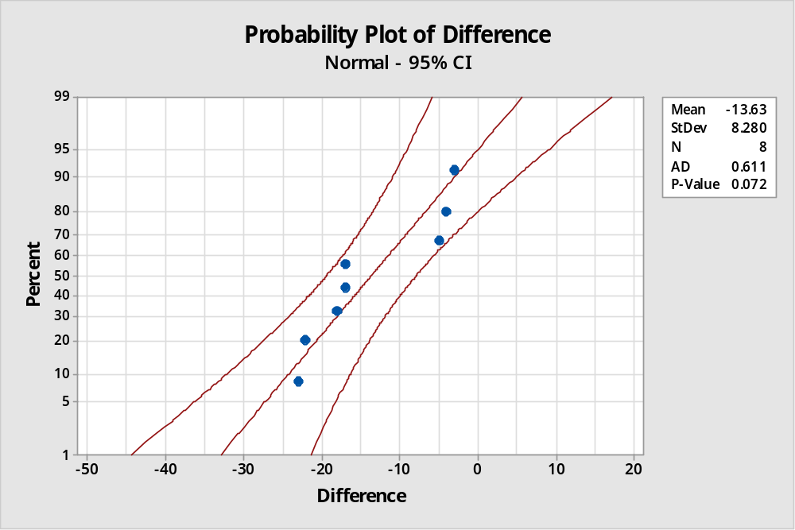

The data are paired as blood lactate levels are recorded before and after exercise for each player. We are assuming that the players are independent of each other and finally the data follows a normal model as the probability plot of the difference in blood lactate levels follows a linear pattern.

95% confidence interval

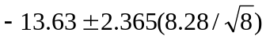 = (-20.55,-6.703)

We are 95% confident that the mean blood lactate level after exercise for elite level racquet ball players is at least 6.7 to at most 20.6 units more than before exercise.

3. A study of the inheritance of speed and endurance in mice found a trade-off between these two characteristics, both of which help mice survive. To test endurance, mice were made to swim in a bucket with a weight attached to their tails (the mice were rescued when exhausted). Here are data on endurance in minutes for female and make mice.

Group | n | Mean | Std Deviation
Female | 162 | 11.4 | 26.09
Male | 135 | 6.7 | 6.69

- Both sets of endurance data are skewed to the right. Why are t procedures nonetheless reasonably accurate for these data?

The sample size is extremely large (larger than 30) so the central limit theorem states that the sample mean from an independent and identically distributed sample tends to follow the normal distribution when n is large.

- Construct and interpret a 95% confidence interval for the mean endurance time of female mice swimming.

If you using the t-table the df = 100 the t* = 1.984

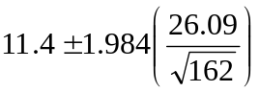= 11.44.0669 = (7.33,15.4669)

We are 95% confident that the mean endurance time of the female mice is between 7.33 and 15.47 minutes.

- Construct and interpret a 95% confidence interval for the difference in the mean endurance times between the female and male mice.

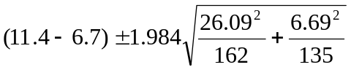(0.4996,8.9004)

We can be 95% confident that the population mean swimming endurance time for female mice is at least 0.4996 minutes and at most 8.9004 minutes greater than the population mean for male mice.

